Table of Contents
1 – CELLS AND ORGANISATION 2
B1 – Cell structure and transport (Y10) 2
B2 – Cell division (Y10) 5
B3 – Organisation and the digestive system (Y10) 8
B4 – Organising animals and plants (Y10) 10
2 – DISEASE AND BIOENERGETICS 12
B5 – Communicable diseases (Y10) 12
B6 – Preventing and treating disease (Y10) 13
B7 – Non-communicable diseases (Y10) 13
B8 – Photosynthesis (Y10) 14
B9 – Respiration (Y10) 16
3 – BIOLOGICAL RESPONSES 18
B10 – The human nervous system 18
B11 – Hormonal coordination 19
B12 – Homeostasis in action (HIGHER) 22
4 – GENETICS AND REPRODUCTION 23
B13 – Reproduction 23
B14 – Variation and evolution 28
B15 – Genetics and evolution 32
5 - ECOLOGY 34
B16 – Adaptation and interdependence (Y10) 34
B17 – Organisation of an ecosystem 36
B18 – The effect of human interactions on ecosystems and biodiversity 36

  - A living collection of misconceptions, key points, diagrams and PCK sourced from @BioRachProject on Twitter, BunsenBlue.wordpress.com and personal experience

1 – CELLS AND ORGANISATION

B1 – Cell structure and transport (Y10)

- Students sometimes think that living things contain cells, rather than being made from cells

- Students need help discerning between Cytoplasm, Chloroplasts, and Chlorophyll. Emphasise:
  - Cytoplasm in all cells, chloroplasts and chlorophyll only in plants and some bacteria.
  - Chlorophyll found inside Chloroplasts.

- Students need help discerning the Cell Membrane and the Cell Wall. Emphasise:
  - Membranes selectively permeable, Walls fully permeable.
  - Membranes in all cells, Walls in plants and bacteria.

- Students may still think all cells are the same size and shape, and that there are no single-cell organisms

- Students incorrectly believe that sperm adaptations include streamlined shape and hard heads to break through eggs.

- Students have particular difficultly discerning the differences between diffusion, osmosis and active transport. Emphasise:
  - Diffusion down concentration gradient, Osmosis down water concentration gradient.
  - Diffusion down concentration gradient, Active transport against concentration gradient.
  - Only Active Transport requires Energy.

- Hypotonic, Hypertonic, Isotonic solutions are inherently very confusing.
  - “Hypo” = low. “Hyper” = “lots of sugar”. “Iso” = same.
  - Hypotonic solutions have a lower solute concentration compared to a cell.
  - Hypertonic solutions have a higher solute concentration compared to a cell.
  - Relate to drinks after exercise:
    - Coke – HYPERtonic. Lots of sugar for your body to convert into energy, but water isn’t really absorbed into the body by osmosis. Higher water concentration in the body’s cell than in the drink.
    - Sports drinks (e.g. Lucozade sport) – isotonic. Contains the same concentrations of salt and sugar as your body should have. If you’ve lost water through exercise, water is absorbed into your body by osmosis, because there’s a lower water concentration in the body’s cell than in the drink.
    - Water – hypotonic. Doesn’t contain any sugars or salts you may need to replace after exercise, but very good at rehydrating you. Water is absorbed into your body by osmosis, because there’s a lower water concentration in the body’s cell than in the drink.

- Students get confused between the similar-sounding terms: Osmosis, Mitosis and Meiosis (also, the latter is often misspelled “Meitosis”).

- Misconceptions that:
  - Some living parts of an organism are not made from cells.

  - Plants are not made from cells.

  - Mitochondria are found in all cells (an example where they are not found is Red Blood Cells, which lose them, alongside the nucleus, during maturation – could be confusing to bring this up, but could be used as a curveball for high-achieving students?)

  - The nucleus controls the cell – ‘the nucleus is a brain’ (I’m a bit back-and-forth with this one. They both ‘store information’, but calling the nucleus a brain seems to imbue it with an agency it simply doesn’t have. THAT SAID, it’s a really convenient-mostly-OK metaphor, and we should probably go ahead and use it. Just be ready to unpick it at A-Level).

- Some lower ability students may harbour the misconception that the nucleus of a cell is the same as the nucleus of an atom.

- When describing the cytoplasm, be sure to fight the misconception that the interior of a cell is solid OR completely filled with water OR filled with air.

- Students may discount the need of individual cells to carry out essential life processes, and ascribe these just to the whole organism itself, such as:

  - Living animal / plant / bacterial cells do not make molecules for the own growth and repair.

  - Animal / plant / bacterial cells do not eliminate their own waste, or need to do so to function.

  - Animal / plant / bacterial cells do not need to extract energy or molecules from food to function.

  - Animal / plant / bacterial cells do not carry out essential life functions for themselves.

B2 – Cell division (Y10)

- Students may harbour/develop misconceptions about DNA, genes and/or chromosomes, such as:

- Each DNA molecule is made from more than one chromosome OR each chromosome is made from more than one DNA molecule.

- Chromosomes do not contain genetic/hereditary information.

- Genes do not contain genetic/hereditary information.

- The genetic code is the number of subunits in a DNA molecule, not its sequence.

- The different cell types found in an individual’s body contain different DNA / different genetic information (This misconception holds across animals and plants. This misconception is also tricky re: sex cells, as they contain a one of each pair of the individual’s chromosomes, and not the ‘complete’ two pairs found in somatic cells).

- Each cell contains only the specific genetic information required for its function.

- Chromosomes and / or genes do not occur in all types of cells.

- Students often think the Cell Cycle and Mitosis are the same thing. Emphasise:
  - Mitosis is a period lasting about 5% of the cell cycle, in which the “nucleus divides and two cells are formed”.

- Mitosis produces two genetically identical daughter cells. The exact size, shape, number of each cytoplasm component, etc, will differ by chance.

- Students may harbour/develop misconceptions, such as:

  - An organism grows because its cells grow, but not because the number of cells increases with time.

  - Or conversely, cells cannot grow, and thus cells and organisms gain in mass and size by cell division only

  - Overall, cells get smaller with every division

  - During cell division, the resulting two cells contain fewer chromosomes than the original cell (Students have failed to appreciate that the original cell had to produce a copy of every chromosome before it could divide into two).

  - The organs of animals and plants do not develop from a single fertilised cell (you will teach them this, but check for understanding - as with everything else!)

  - In early development, an organism grows in size and mass, but this isn’t attributed to cell division or cell growth.

  - Chromosomes are located in sex cells but not inside any other types of cell.

- Students naturally assume that stem cells are found in the stems of plants, this can block learning the definition that they are cells that can differentiate into any cell type.

- Plant meristem is found in the tip of the shoot or roots (or between xylem and phloem).

- When asked to evaluate the use of stem (or different types of stem) cells, students often fall on their ideas rather than evaluating the information given to them in the exam question (this is explicitly an exam question-based issue, not an understanding one).

- Students (and adults!) think that “Plants are slow” (in fact, their cellular processes are actually very quick – elongation of plant cells can occur in just a few hours to reorient the plant to face the light).

B3 – Organisation and the digestive system (Y10)

- Students may harbour/develop misconceptions about digestion such as:

- Food is burned during digestion (“burning calories”).

- Molecules from food are distributed around the body by way of special tubes, not the circulatory system.

- Molecules from food move directly from the mouth to the rest of the body.

- Food freely moves around in the body (no link to digestive structures).

- Simple sugars / fatty acids / amino acids have to be broken down into smaller pieces before entering cells.

- Proteins / complex carbohydrates do not have to be broken down into smaller pieces before entering cells in the body.

- Carbohydrates, fats and proteins from food are unchanged before being used by the body.

- The digestive system and circulatory system are not connected.

- If food cannot be digested, it will stay in the body forever.

- Digestion helps us use food, but it is not necessary for us to use food.
- The small intestine is short, and the large intestine is long.

- Students misclassify enzymes at low temperatures as denatured, and at high temperatures as killed or dead.

- Students describe the function of stomach acid as digesting/breaking down food. Emphasise:
  - Optimum pH for pepsin enzyme to digest proteins
  - Kill pathogens on food

- Students describe the function of bile as digesting/breaking down lipids. Emphasise:
  - Emulsifying lipids into smaller droplets, to increase surface area for lipase action.
  - Neutralising stomach acid to provide optimal pH for intestine enzymes.

- Students can confuse function and products of the liver, pancreas and kidneys.
  - Function:
    - Liver – detoxification and glycogen storage
    - Pancreas – enzyme production and sugar homeostasis
    - Kidney – controlling water and mineral loss
  - Production:
    - Liver – bile
    - Pancreas – digestive enzymes, insulin and glycogen
    - Kidney - urine

B4 – Organising animals and plants (Y10)

- Students may harbour/develop misconceptions about the heart and blood, such as:

- Blood freely flows through the walls of blood vessels.

- Blood does not carry oxygen / carbon dioxide / simple sugars around the body.

- Gas, water and food molecules pass through artery and vein walls, rather than capillaries.

- Capillaries are only found in organs like the lungs and intestines (e.g. where they are explicitly taught to students re: molecule exchange).

- Capillaries are found only in the extremities (hands and feet – again, where they are explicitly taught re: homeostasis).

- Anything can pass through the walls of capillaries.

- Nothing can pass through the walls of capillaries.

- The heart is the mixing place for air and blood.

- Blood doesn’t transfer carbon dioxide to the lungs, and they do not eliminate it from the body (in contrast to students largely being happy that the lungs take in oxygen and the blood carries oxygen away from the lungs).

- Blood in veins is blue.

- If you stand on your head, your feet won’t get any blood.

- Students can confuse white blood cells and platelets. Emphasise:
  - WBC are whole cells, and Platelets are cell fragments.
  - WBC kill pathogens, whereas clotting by platelets prevents the entry of pathogens.

- Blood is pumped around most of the body by the heart, but contraction of skeletal muscles ensures blood flow in veins (e.g. leg muscles forcing blood up legs against gravity).

- Students confuse statins and stents for treatment of coronary heart disease.
  - Statins are medicines that reduce blood cholesterol levels.
  - Stents are metal meshes that open up blood vessels by compressing fatty deposits.

- Students often think pacemakers treat all coronary heart disease, rather than just irregular heart rate.

- Misconceptions about the lungs forcing air in and out, rather than diaphragm control:
  - Flattens: volume up, pressure down, air in.
  - Returns dome shape: vol. down, pres. up, air out.

- Students need to state that capillaries and alveoli have thin walls, NOT thin cell walls.

- Transpiration only defines the loss of water vapour by evaporation from leaves and parts of the stem. (Transport of water in xylem is referred to as the transpiration stream).

- Students can also routinely confuse transpiration and translocation.

- Students are bad with chemical symbols: a mishmash of CO₂ / CO² / CO2

2 – DISEASE AND BIOENERGETICS

B5 – Communicable diseases (Y10)

- A classic: antibiotics do not work against viral diseases.

- Cure vs. Treatment: completely remove disease vs. lesson or slow its progression.

- Malaria is not caused by bacteria or a virus. Students need to be reminded of protists.

- Confusion between cilia and villi. Emphasise:
  - Cilia:
    - Tiny hair-like projections from single cells
    - Wafts mucus (and eggs in the oviduct). Found in the trachea, bronchi and oviducts.
  - Villi:
    - Finger-like projections made of many cells
    - Only found in the small intestine, to increase surface area for absorption of nutrients by diffusion.

- Diseases are often erroneously described as being caused by ‘germs'. It is frequently thought that all bacteria are pathogenic too.

- [HIGHER] Incubating bacteria no higher than 25 degrees reduces the risk of growing harmful bacteria NOT because higher temperatures denature enzymes or kill the bacteria.

- Students confuse antibiotics and antiseptics, and sometimes fail to remember they both kill pathogens.

B6 – Preventing and treating disease (Y10)

- Terminology confusion between antigen, antibody and antibiotic.

- [HIGHER] Hybridomas can confuse students. Emphasise: Hybridomas as a combination of a B lymphocyte and tumour cell.

B7 – Non-communicable diseases (Y10)

- Students can think that risk factors are the consequence of a disease, rather than something that increases your chance of developing it.

- Students think cancer cells only spread around the body via the blood, but miss the lymphatic system, where WBC and fats are transported.

- Emphasise that students need to be specific about how they describe good and bad diets: “low/high cholesterol/fat”, not just “poor/unbalanced diet”

- Students confuse the treatments for type 1 and 2 diabetes:
  - Insulin injection and pancreas cell transplant are for type 1 only.
  - A low carbohydrate diet and regular exercise is used to treat type 2.

- Students need to be more specific about the effect of cigarette smoke tar:
  - Damages cilia is good
  - “Narrows airway” / “stuck in lungs” is true, but not specific enough.

- Ionising radiation can mutate DNA, NOT CELLS. “Cell mutation” isn’t a thing.

B8 – Photosynthesis (Y10)

- Students may harbour/develop misconceptions about photosynthesis and plant metabolism, such as:

- Carbon dioxide, water and minerals are “food” for plants / animals.

- Food is a source of energy, but not a source of building materials (or vice versa).

- Food simply “keeps things alive”, rather than having a specific function.

- Food is any material that organisms take in from their environment.

- Plants get their food / mass from the soil (including a misconception that starch, sugar and protein is absorbed from the soil).

- Food enters a plant through the roots.

- Plants make sugars from minerals and water.

- Plants have multiple food sources, not just the sugars that they make from carbon dioxide and water.

- Molecules from food are not stored in the bulbs or seeds of plants (or stored at all).

- Plants use oxygen during photosynthesis.

- Carbon dioxide is absorbed by plants through their roots.

- General note: students often find it difficult to understand that plants exchange gases with their environment at all.

- Glucose is a carbohydrate:
  - Carbo (C)
  - Hydr (H)
  - Ate (O)

- Specificity of describing limiting factors:
  - “Limiting factors are factors that affect the rate of photosynthesis” – NO.
  - “Factors that stop the rate of photosynthesis from increasing further” – YES.

- Remember that what’s occurring at each phase of a limiting factors graphs can be unintuitive.
  - Gradient = increasing rate = no limiting factor
  - Horizontal line = steady rate = limiting factor in play

- A classic: photosynthesis occurs when there’s light, respiration occurs all the time.

B9 – Respiration (Y10)

- Students may harbour/develop misconceptions about respiration, such as:

- Respiration is the opposite of photosynthesis.
- Respiration only happens at night in plants.

- Energy is NOT produced, created, or made. Energy is provided or released.

- Excess glucose is turned into different molecules that act as chemical energy stores, in animals and plants:
  - Animals: Glycogen
  - Plants: Starch

- Effects of exercise on the body:
  - Unseen:
    - Glycogen turned into glucose
  - Seen:
    - Heart rate up
    - Breathing rate up
    - Sweating
    - Red face

- Anaerobic respiration produces different things in animals vs plants and yeast:
  - Animal: Lactic acid – which is then broken down into CO₂ in the liver, when enough oxygen is breathed in (oxygen debt).
  - Plant and Yeast: Ethanol and CO₂.

- A classic: Respiration is not the same as breathing.
  - Respiration:
    - Biochemical reaction
    - Breaks down glucose to release energy
    - Happens in all cells
  - Breathing:
    - Mechanical process
    - Takes in oxygen and released carbon dioxide
    - Happens in gas exchange systems only.

- Students often think plants to not “do respiration”
  - It happens in ALL cells!

3 – BIOLOGICAL RESPONSES

B10 – The human nervous system

- Emphasise differences between sensory and motor neurones.

- Emphasise that both muscles and glands are effectors.

- Students confuse neurotransmitters and nerve impulses across synapses and down neurones (emphasise: synapses are gaps between neurones)
  - Electrical impulse > neurotransmitters diffuse across synapse > trigger another (new) electrical impulse in the next neurone
  - Electrical impulse does not move across the synapse

- Student’s often confuse the pupil as a tangible ‘object’ in the eye’s structure, rather than just the hole that allows light in. Can be confused with the iris.

- Pupils do not easily make links between the brain, nervous system, hormones and behaviour; nor between behaviour and survival.

B11 – Hormonal coordination

- Students often mistake insulin and glucagon for enzymes – they are hormones.

- Students often state that insulin and glucagon “control blood glucose levels”. This is too vague.
  - Insulin decreases blood glucose levels
  - Glucagon increases blood glucose levels

- Confusion between: Glucose, Glycogen, Glucagon, Glycerol
  - Glucose
    - simple hexose (6C) sugar, used in respiration
  - Glycogen
    - complex carbohydrate made of glucose sugars bonded together.
    - broken down into glucose for respiration.
    - chemical energy store, stored in the muscles and liver
  - Glucagon
    - a hormone (made of protein).
    - increases blood glucose levels.
    - binds cells of the muscles and liver, causing them to convert glycogen into glucose, which is released into the bloodstream.
  - Glycerol
    - a molecule (organic alcohol) that makes up part of lipids (along with 3 fatty acid chains)

- Type 1 and 2 diabetes differences can often be confusing:
  - Type 1
    - Body doesn’t produce enough insulin
    - Requires insulin injection / pancreas transplant
  - Type 2
    - Body stops responding to insulin
    - Exercise and low carb. diet – not insulin injection
- The menstrual cycle can be taught confusingly or on-point; there is no in-between. Use the fantastic diagram below.

  - “Full On Living Potential”
    - FSH > Oestrogen > LH > Progesterone

  - Emphasise: the hormones travel via the bloodstream between the two glands, to trigger than release of the ‘next’ hormone

  - “The menstrual cycle is a dialogue between two glands”

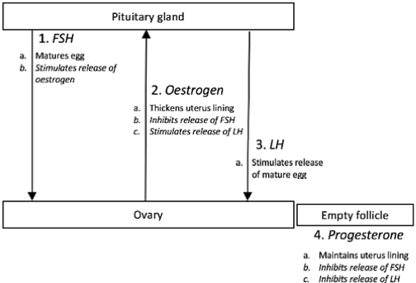

  - From the fantastic examples given by https://bunsenblue.wordpress.com/2019/12/04/clear-teacher-explanations-2a-dual-coding-processes/

- Confusion about auxins: promote shoot growth but inhibit root growth.

- Auxins ‘hate light’, so concentrate on the darker side of a shoot.

  - When a shoot is small, light falls evenly everywhere on it
    - Auxin is evenly distributed on the shoot
    - The shoot grows upwards

  - When a shoot is tall, light falls more strongly on one side
    - Auxin becomes more concentrated on the opposite (darker) side
    - The darker side of the shoot grows quicker than the lighter side
    - As it grows, the shoot bends towards the light side

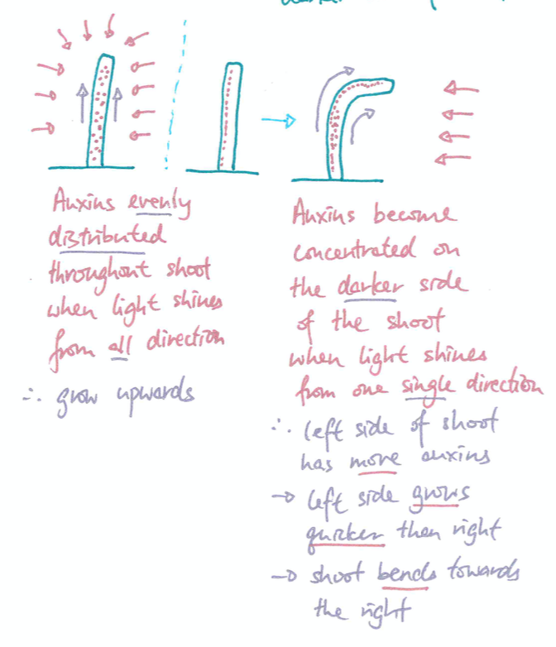

B12 – Homeostasis in action (HIGHER)

- Student confusion about Vasodilation and Vasoconstriction:

  - Capillaries do not dilate or constrict. There are no muscles to do so.
  - Dilation and constriction happen in the blood vessels that lead to the capillaries (on the skin surface)

- Confusion about Urea vs Urine:
  - Urea:
    - Nitrogenous waste molecule
    - Produced by the breakdown of amino acids
    - Produced in the liver

  - Urine:
    - The liquid we excrete
    - Contains urea, excess water and mineral ions
    - Produced in the kidney

- Anti-Diuretic Hormone (ADH) control can cause confusion:

  - Dehydration:
    - More ADH released by pituitary gland
    - Kidney tubules become more permeable
    - Kidneys reabsorb more water
    - Smaller volume of concentrated urine produced

  - Well hydrated:
    - Less ADH released
    - Kidney tubules become less permeable
    - Kidneys reabsorb less water
    - Larger volume of dilute urine produced

- Dialysis fluid is not pure water, but same concentration of contents as healthy blood. There is no urea in dialysis fluid.

4 – GENETICS AND REPRODUCTION

B13 – Reproduction

- Plants do both asexual and sexual reproduction.
  - Students think of sexual reproduction as 'mating', and therefore think plants can’t reproduce sexually

- Asexual reproduction can be misconstrued as producing ‘weak’ individuals, with sexual reproduction producing ‘superior’ ones

- Students are easily confused by similar reproduction terminology:

  - Asexual – by mitosis only
  - Sexual – by mitosis and meiosis

    - Meiosis makes gametes (in testes / ovaries)
    - Fertilisation (gametes fuse to form a zygote)
    - Mitosis of the zygote cell turns it into an embryo

      - Zygote: the single original fertilised cell formed by fusion of a sperm and an egg cell

      - Embryo: multicellular – the rapidly dividing bundle of cells formed by mitosis of the zygote. In humans, encompasses the first division of the zygote through to roughly 8 weeks after fertilisation (including a number of more specifically named stages).

- Many potential misconceptions are either already possessed or accidentally developed by students, including:

- Chromosomes are located in sex cells but not inside any other types of cell.

- In sexually reproducing organisms half of the offspring’s cells contain DNA from the mother, and the other half from the father.

- Some characteristics of an offspring are determined by the parents’ environmentally acquired characteristics (Mike: there is evidence to suggest this may actually occur in a small number of circumstances, through epigenetic changes. Of course, further research could later confirm this to be false. A recommendation to watch this space and remember that scientific understanding adapts to new knowledge!).

- Each parent contributes genetic information for certain characteristics and not others (e.g. a child has their father’s nose and their mother’s eyes, etc).

- Boys inherit traits from their father and girls from their mother.

- DNA / genetic information / traits are inherited from only one parent.

- The genetic information in a fertilized egg is divided up among different cells as they divide during development.

- In asexually reproducing organisms, half of the parent’s DNA is passed to its offspring (Students have failed to appreciate that the original cell had to produce a copy of every chromosome before it could divide into two).

- In asexual reproduction, half of the offspring’s DNA is the same as the DNA in its one parent.

- In asexual reproduction, the amount of DNA that is identical (compared to the parent) varies from offspring to offspring.

- The specialised cells used for reproduction contain the same number of DNA molecules / chromosomes as the other cells of the body.

- A fertilized sex cell has the same number of chromosomes as an unfertilized sex cell.

- Mutations that occur in a parent’s cell (other than a gamete) will be transferred to their offspring.

- Larger environmentally acquired characteristics are passed on to offspring (e.g. a father loses a finger in childhood, which means his offspring will also have one finger less).

- Offspring resemble parents because trait-bearing “particles” are transferred from parents to offspring during reproduction (e.g. “particles of blue” for blue eyes).

- Different phenotypes between siblings are a result of genetic differences alone.

- Chromosomes only look like an ‘X’ shape after the cell has replicated its DNA to prepare for mitosis.

- The differences between Mitosis and Meiosis are often difficult to learn:

  - Mitosis
    - Divides once
    - Chromosomes form along the centre of the cell
    - Process forms two daughter cells…
    - …which are genetically identical
    - Used for growth and repair

  - Meiosis
    - Divides twice
    - Chromosome pairs from along the centre of the cell in first division, then the chromosome line up along the centre in the second division
    - Process forms four daughter cells…
    - …each containing ½ of the original cell’s genetic information
    - Used to produce gametes (sperm and egg).

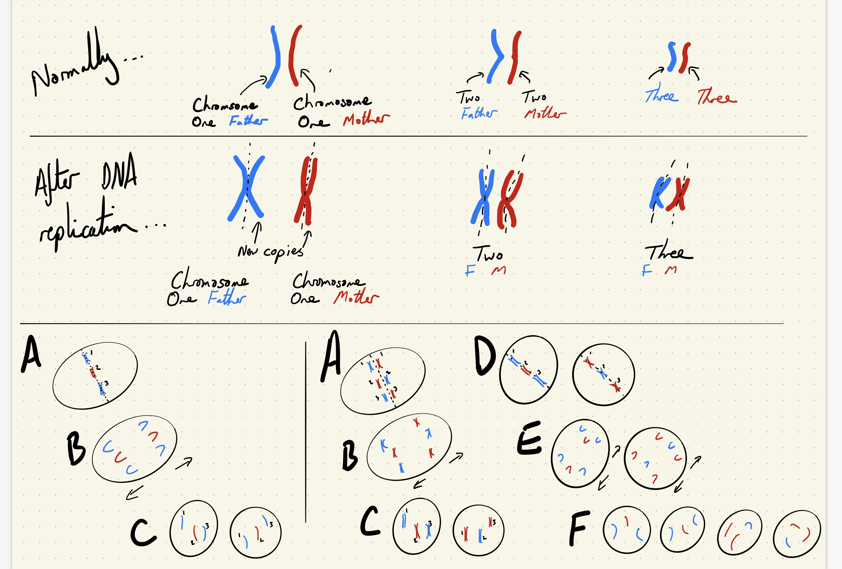

- A lot of confusion about the size and relationship between DNA, Gene and Chromosome
  - DNA
    - Molecule that carries genetic information
    - Made up of nucleotides [HIGHER]
  - Gene
    - A section of DNA that codes for a protein.
    - This protein then determines a characteristic.
  - Chromosome
    - A structure that carries genes.
    - Found in the nucleus

- Students often refer to “inheriting a characteristic”
  - Better is: “inherit a (specific) allele or gene, that codes for a (specific) characteristic

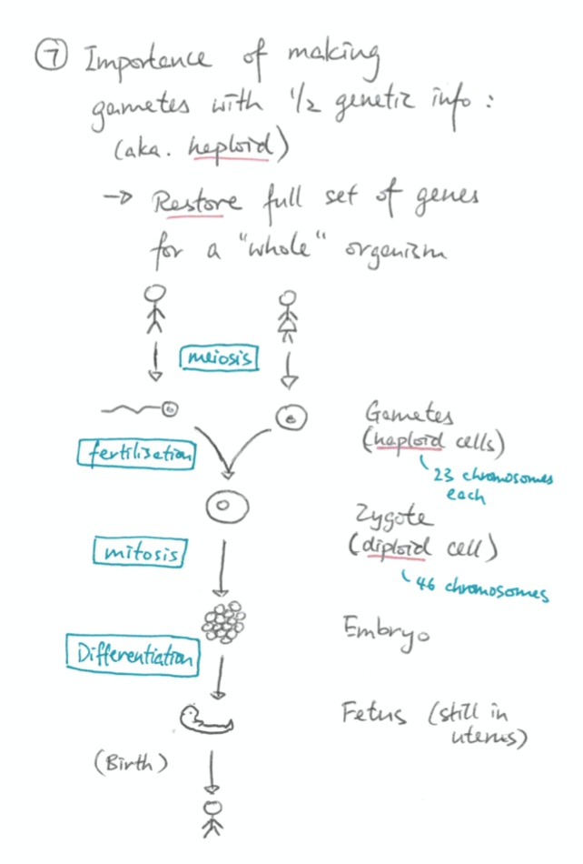

B14 – Variation and evolution

- Organism’s cannot “choose to” adapt to a new environment (they also do not “get used to” the new environment.
- i.e. the belief that adaptation is undertaken to satisfy an organism's need: the Lamarckian view in which transmitted characteristics are acquired during the lifetime of the animal
- Individuals do not evolve!

- Watch out for misconceptions about human evolution, such as:
  - Some human groups have not evolved as much as others
  - There are different human races, which aren't all from same gene pool.

- Random mutation means pre-existing genetic variation (e.g. different alleles) – it is not the result of environmental factors

- New environments lead to the process of natural selection, in which nature selects for the advantageous characteristics of some of the population’s individuals, which are encoded by the alleles they possess, against disadvantaged individuals that don’t have them.

- Those individuals in the population that possess the advantageous characteristics (which are coded by their advantageous alleles) survive, reproduce and thus pass on their advantageous alleles.

- Over time, more (or all of) the individuals in the surviving population possess the advantageous allele.

- There is a big grab-bag of misconceptions about variation and evolution that students may form:

- Mutations that occur in a parent’s cell (other than a gamete) will be transferred to their offspring.

- Species that have no obvious or superficial similarities have no similarities to each other at all.

- Throughout history, extinctions are rare and have only happened because of human activity.

- Except for minor fluctuations from year to year, environmental conditions (air / land / sea) have stayed the same throughout the history of the earth.

- Extinction only occurs due to massive events such as asteroid collisions

- All species began at the same time and still exist today. Very few extinctions have occurred.

- Changes to the environment cannot lead to changes in a species living in that environment (over time).

- Individuals can evolve.

- Change occurs in the inherited characteristics of populations over time because organisms observe other more successful organisms and model their appearance or habits.

- Evolution happens when individual organisms “get used to” new conditions gradually.

- Sudden environmental change is required for evolution to occur

- Evolution occurs quickly.

- Changes in a population occur through gradual change of all members of that population, not from the survival of a few individuals that preferentially reproduce.

- Change occurs in the inherited characteristics of a population over time because of the use or disuse of a particular characteristic.

- Change to the characteristics of populations is always random, and not influenced by the favourability of the change to a given environment.

- Individuals can deliberately develop new heritable traits because they need them for survival.

- Evolution is a driving ‘force’ (a misconception of ‘causing’ progress), rather than an outcome of selection pressures acting on largely random genetic changes.

- All mutations are bad (‘mutation’ associated with negativity).

- The internal chemistry, appearance and behaviour of a species does not change over time.

- Except for differences between males and females, between old and young, all organisms look and act the same.

- Differences among all individuals in a population are trivial and unimportant. They are all essentially genetically identical.

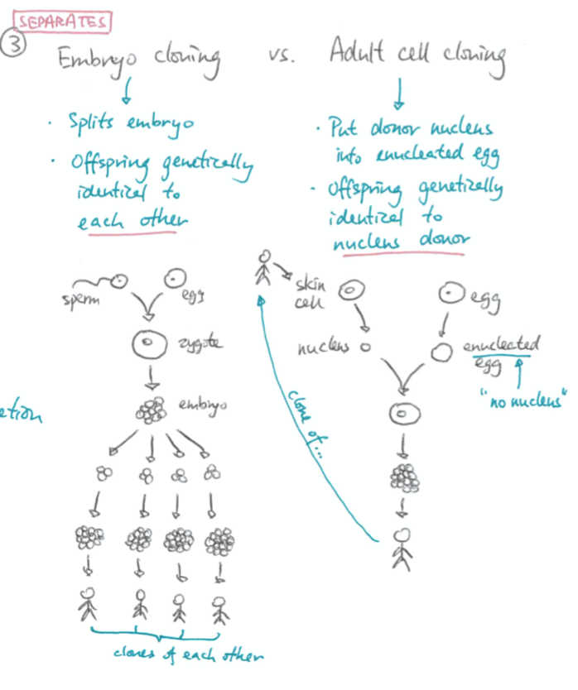

B15 – Genetics and evolution
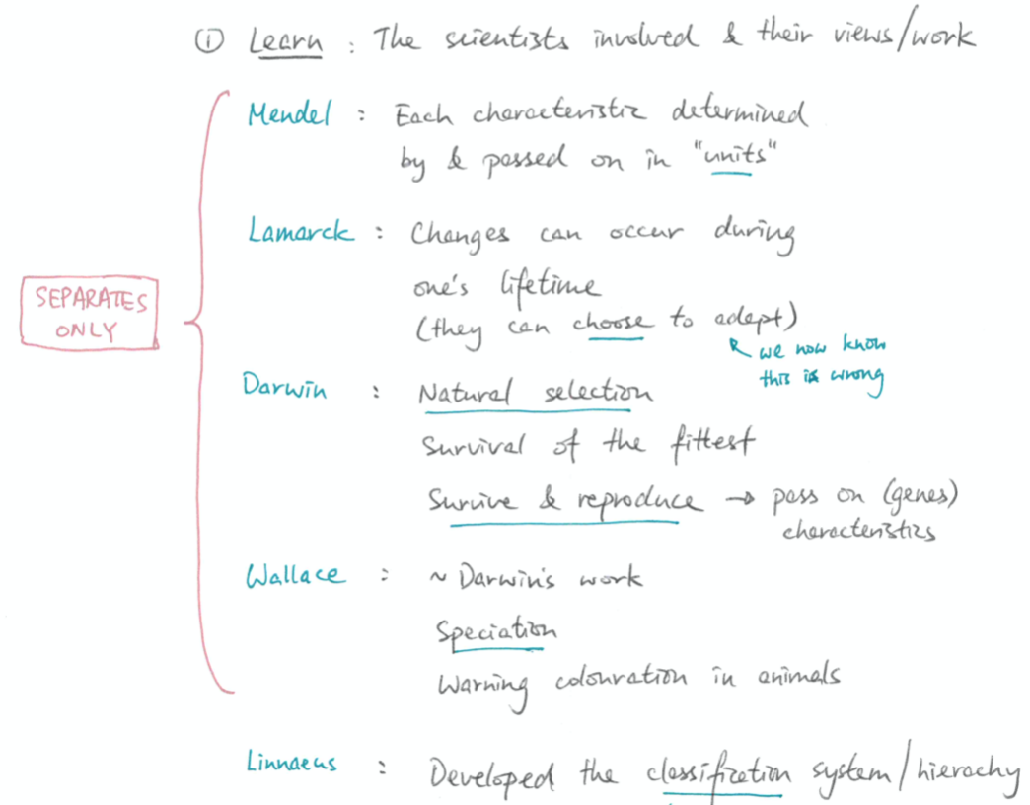

- Linnaean classification: Kingdom, phylum, class, order, family, genus, species

- Separating abiotic and biotic factors can be confusing
  - Relevant biotic factors that may lead to extinction:
    - Successful predators
    - Successful competition
    - New pathogens and thus, diseases

- There is a big grab-bag of misconceptions about variation and evolution that students may form:

- Humans do not share a common ancestor with other living organisms.

- Members of different species do not share a common ancestor.

- Species that are similar can share a common ancestor, but those with no obvious similarities cannot share a common ancestor.

- Plants and animals have no common ancestor.

- Insects are not animals.

- Grass and seeds are plants, but a carrot is a vegetable.

- An oak tree is not a plant.

- A cat is an animal, but a human is a person and not an animal.

5 - ECOLOGY

B16 – Adaptation and interdependence (Y10)

- Students need to make sure that they use information given in exams to answer questions about adaptation.

- Similar to the last unit, keep abiotic factors and biotic factors straight.
  - Abiotic factors affecting organisms:
    - Animals: Oxygen levels (not CO₂) – needed for aerobic respiration
    - Plants: Carbon dioxide levels (not O₂) – needed for photosynthesis

- Emphasise specifics of sampling:
  - Random sampling:
    - Use random number generator to get coordinates to place quadrats – GOOD
    - “Randomly” throw quadrats after spinning around a bit – BAD

  - Quantitative sampling: Estimate population size
  - Transect sampling: Determining a species’ population distribution

- Common misconceptions about interdependence include:

- If a population in a food web is increased or decreased, there will be little to no effect on other organisms elsewhere in the web (beyond the directly affected food chain).

- If a population in a food web is increased or decreased, every other population in the web will be affected in the same way.

- If a population in a food web is increased or decreased, there will be no effect on populations below it in the food chain (a misconception that only predators affect food chains).

- Population exist in states of either constant growth or decline.

- Organisms higher in a food web eat everything that is lower in the food web.

- The top predator in a food web will never be significantly affected by changes in the rest of the web.

- A species high on the food web is a predator of everything below it.

- Carnivores could exist in a plant-free world if their prey produce enough offspring.

- Competition between organisms always involves direct, aggressive interaction.

- Plants do not compete for resources (including light and space).

- Organisms of the same species do not compete.

- Organisms of different species do not compete for the same resources.

- Animals do not compete for shelter or water.

- Only animals can be infected by pathogens (students largely ignore this in plants).

B17 – Organisation of an ecosystem

- Regarding the water cycle, check student ability to separate and explain condensation and evaporation.

B18 – The effect of human interactions on ecosystems and biodiversity

- Greenhouse gases that lead to global warming:
  - YES: Carbon dioxide, methane, water vapour
  - NO: Sulphur dioxide, nitrous oxides
- Gases that lead to acid rain (which isn’t global warming)
  - YES: Sulphur dioxide, nitric oxides
  - NO: Carbon monoxide/dioxide

- Ensure student write carbon dioxide as CO₂, not CO2 or CO².
  - If in doubt, write out the full name.

  - A living collection of misconceptions, key points, diagrams and PCK sourced from @BioRachProject on Twitter, BunsenBlue.wordpress.com and personal experience

